A REPORT OF PROJECT ON MOVIELENS DATASET AND FEATURE ENGINEERING
MovieLens dataset is a small portion of dataset that contains a dataset of movie ratings and metadata collected by the Group Lens research group. It contained files like movie files, links, ratings, and tags.
Two files (Movie and rating files) were merged together using on “movieId|” using “outer join”. It was assigned to a variable named (Movie_ratings). Information about the table was found and in the table were about 100854 rows and 6 columns respectively.
DATA CLEANING
I checked for duplicates and missing values, there was no duplicates recorded but 18 rows of missing values was recorded in the userId table, I cleaned it by dropping those rows.
Timestamp datatype was converted to “datetime” datatype.

FEATURE ENGINEERING
These are the following features that was created and the reasons for creating them;
- Release Year: The release year is the year the movie was released. It was extracted from the ‘title’. It is useful for popularity trends and cold start for new movies.
- Number of Genres: The number of genres was extracted from the ‘genre’. It is useful for generating appeals from audiences.
- Rating Year: The rating year was extracted from ‘timestamp’. It is useful in analyzing rating behavior overtime.
- Rating Month: The rating month was extracted from ‘timestamp’. It is useful in discovering the seasonal rating patterns.
- Number of Rating: The number of ratings was extracted from rating. It shows the amount of rating a particular movie has. It is useful for popularity of the movie.
- Movie Age at Rating: Movie age at rating was extracted from the subtraction of (rating year-release year). It shows how old the movie was before it was rated.

EXPLORATORY DATA ANALYSIS AND KEY INSIGHTS
Below are the key insights generated from the analysis;
- Most movies are rated between 3.0 and 4.5 stars. This indicates positive ratings.
- Drama, comedy, action are the most common genres. Drama is the most frequent.
- The highest number of genres per movie is 3
- The most common movie tags are, ‘In Netflix queue’, ‘Atmospheric’, and ‘Superhero’.
- Movies with more tags usually have more user engagement.
- There was a steady rise in movie release as at 2000, this shows growing activity.

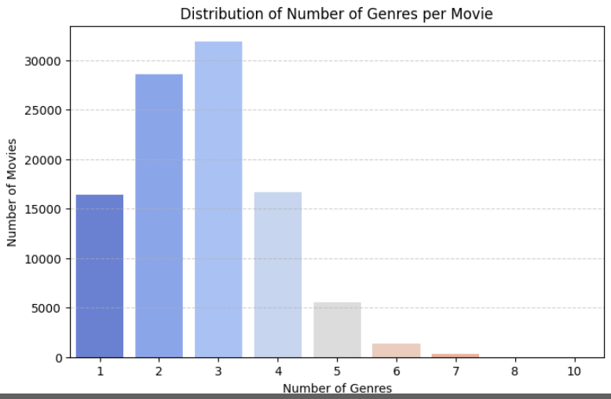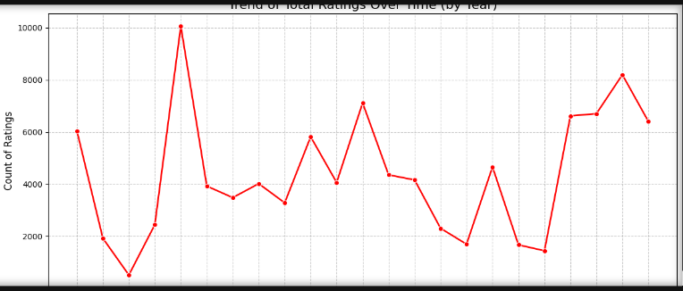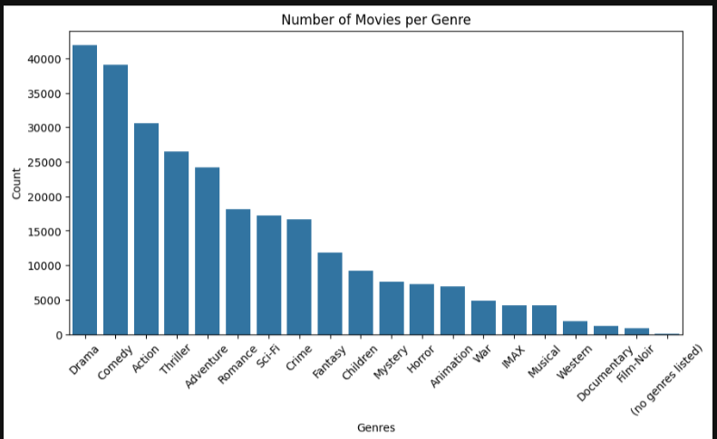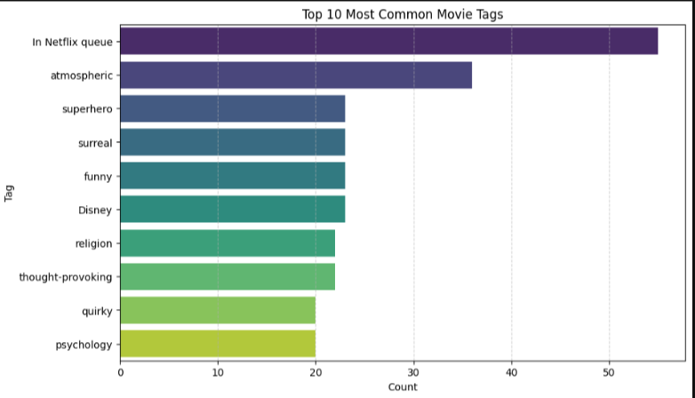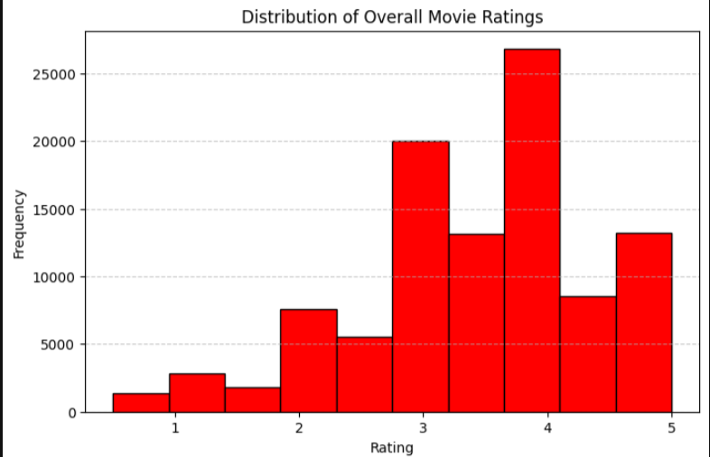

RECOMMENDATION SYSTEM BUILDING
Rating Trends: This rating trend informs time-based suggestions. The system should be time sensitive and time aware. The season to which movie is produced should be considered.
Number of ratings: This helps rank movies and also measure the popularity of the movie.

